Week 1 – Introduce yourself!

This is an Individual Lab!

|  |  |
| --- | --- |
| Name: | * Rendell Velasco |
| Student Number: | * 140014218 |
| Where are you from: | * Philippines |
| What languages do you speak: | * English * Tagalog |
| Work experience: | * None |
| Where did you go to school before this: | * Dr Bette Stephenson Adult School |
| What program are you in? (CPP, CPA, CPAC) | * CPA |
| How are you doing at school? | * A student that gets by because the experience is more important than the numbers. |
| List students in the class that you would like to work with: | * Anyone |
| List the students in the class that you don’t want to work with (it happens!): | * No one |
| Would you prefer to work with a group that participates online? Or in the lab? | * In the lab |
| During the day, when are you most productive with school work? | * Early in the morning before the rest of the people in my home are moving. * Middle of the day, |
| What do you like to do outside of school?: | * Reading Manga * Watching Anime * Playing Games |
| Academic Integrity issues will not be tolerated in this course. Complete Seneca’s Academic Integrity module and share the link to your badge  https://cfdev.senecacollege.ca/tl/forstudents/integrityinaction/ | https://factory.cancred.ca/v1/assertion/6917337cf0ae5243bc5075f2c4a10032bc530ba6 |

Reflect on a project that you’ve participated in. This project does not have to be Information Technology related. Did you team use Predictive, Agile or a hybrid methodology. Tell me about your experience.

I haven’t participated in in a project before.

Download Visual Paradigm and practice! Recreate the class diagram and object level sequence diagrams in the attached material. Be sure to change the note to reflect your name and section. Copy the diagrams into this word document and attach the .vpp file to your assignment.

Class Diagram

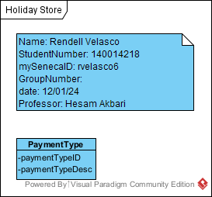

Object Level Sequence Diagram

